Table of Contents
1. Scope 2
2. Introduction 2
3. Dataset Preparation 3
4. ML Models 3
5. Data splits and cross-validation 4
6. Conclusions 6

Scope
Project title: Predicting Real Estate Prices Using Machine Learning
Main research question:
Which machine learning model predicts real estate prices more accurately: Linear Regression or Random Forest Regressor?
Additional research questions:
- Which features are most useful for predicting real estate prices?
- Does Random Forest perform better than Linear Regression on this dataset?
- How does model performance change across the three required data-splitting settings?
- Does hyperparameter tuning improve the predictive performance of the models?
- Do the results suggest overfitting, underfitting, or good generalisation?

Introduction
I have decided to choose my subject out of Housing and Zoning section. In my work I am going to achieve my goal: to predict the real estate prices based on ML. My dataset is a collection of real estate data from Taiwan. I believe that prediction of real estate prices may result in good and proper future investments in estate. I hope ML will meet these data and the result.
My original file contains columns named: ‘No’ – number of the record, ‘X1 transaction date’ – transaction year, ‘X2 house age’ – house age, ‘X3 distance to the nearest MRT station’ – metro station distance, ‘X4 number of convenience stores’ – amount of convenience shops nearby, ‘X5 latitude’ – latitude of the house, ‘X6 longitude’ – longitude, ‘Y house price of unit area’ – price of the house for the unit. The last feature will by my target value (‘Y house price of unit area’).
In my next chapter I will focus on answer of my project assignment question above. My work will focus on the Linear Regression and Random Forest Regressor.

Dataset Preparation
After some exploration of my data I can conclude that my dataset has 414 observations & 8 columns. The first column named ‘No’ has been removed directly as I don’t need it. Now I am going to work only with 7 columns. My data are integers and floats.
My target value will be the last attribute: ‘Unit are price’. The mean price per unit are is 37.98 Dollars (the original value is Taiwan dollar, but in my research for simplicity I am going to say Dollar). The max price per unit area is 117.5 Dollars, which is much more higher than my median which can indicate the outliers – I will work on it later on.
There is no duplicated or missing values. The corelation shows that the metro station distance reflects -0.67 with the unit are price. The amount of convenience shops has kind of strong relationship 0.57 with the target. The fields related to location might have much more important effect on the price – target.

ML Models
In the linear regression model the mean squared error gives 69.67. This outcome shows average squared difference between the actual prices and predicted ones. Lower values show smaller errors when comparing models. The r-squared score was 8.35 - RMSE treats larger errors more heavily. R² = 0.648 - model explains 64.8% of the variations in prices in the test section.
In the random forest regressor the mean squared error reflects less than for the linear regression – 38.19. The The prediction error scale is 6.18, which is smaller than for the previous model. R² = 0.807. -- model explains 80.7% of the variations in prices in the test section.
The better choice between those two models will be the random forest . It predicted a higher R² score and lower RMSE and MSE. As a result, the random forest predicted house prices with better accuracy. The linear regression seems to be easier for an interpretation, the random forest is more suitable for the complex relationships. In my further research.

Data splits and cross-validation
According to assessment requirements I spited dataset into train and test parts, three sizes: 5%,15% & 25% with results:
Model | Test size | MAE | RMSE | R2
Linear Regression | 5% | 6.45520 | 9.18516 | 0.51833
Linear Regression | 15% | 6.67896 | 8.86549 | 0.57659
Linear Regression | 25% | 6.31753 | 8.13232 | 0.64200
Random Forest | 5% | 3.98054 | 6.53091 | 0.75649
Random Forest | 15% | 4.36044 | 6.28819 | 0.78699
Random Forest | 25% | 4.28061 | 6.01032 | 0.80446

Two Machine Learning modes has been used: Linear Regression & Random Forest. To check the models I used the mean absolute error (difference between predicted and actual values), root mean squared error and R-squared.
I my case, the Random Forest performed much more better than the Linear Regression model in between the splits. Taking into consideration a 25 % split size of the test, the Random Forest Model achieved the R-squared score 0.804 in comparison with the LR model 0.642. Random Forest got lower RMSE (6.01) when Linear Regression got it up (8.13).
To have a better look, there is a plot below showing up the performance between Linear Regression and Random forest:
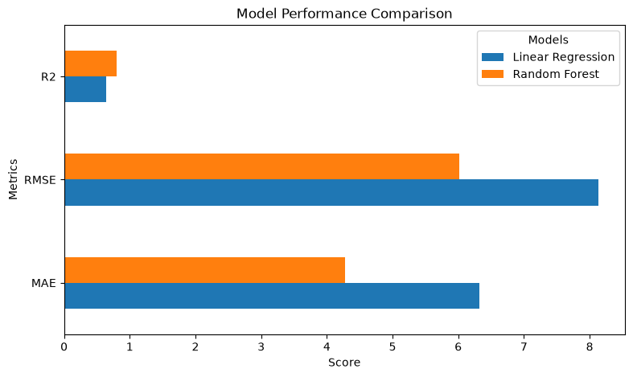

The above plot of actual and predicted vales for Linear Regression and Random forest shows up that Random forest was more suitable for predicted values. It might relate for more relationships between features and prices which indicate for more complex matter than the simple linear relation.
Cross-validation has been applied too. It reflects how variable subsets reliable are. Random Forest achieved higher mean cross validation R-squared scores in all research. Random Forest results where 0.69, 067, 065 while compared with Linear Regression 0.57, 0.59 & 0.56.

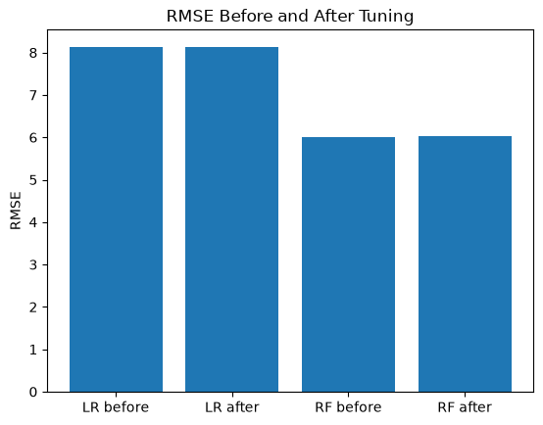
The above chart shows RMSE before and after Hyperparameter Tuning for Random Forest & Linear Regression. For LR the RMSE didn’t change. The RMSE went up, just slightly for RF. The hyperparameter didn’t improve tuning for both models.

Conclusions
My purpose of this project was to find dataset, clean it, do some research on it.
I compared two models: Random Forest & Linear Regression. The modes has been used to predict the prices of the houses. Out of result, Random Forest got better marks between all three splits 5,15 & 25%. You can Clearly notice the best score for the R-squared of 25% split: 0.804 and 6.01 for RMSE.
One of the features: nearest metro station distance showed that the distance of the metro had a big influence on the predictive price as below.
Feature | Importance
Transation date | 0.02781
House age | 0.18499
Neartest metro station distance | 0.57913
Convenience store amount | 0.02163
Latitude | 0.10932
Longitude | 0.07711

My dataset contained 414 tuples and 6 columns. I tried to focus on the most important aspects of my work to achieve my best.
The scope was not huge, yet I managed to get some results. There are just two more plots as a total conclusion showing predictive and actual prices for both Linear Regression & Random Forest:


